Name: Pranav Dilip Hingankar

Batch**:** T6  
PRN**:** 2020BTECS00040

**SET Lab Assignment No - 9 - Selenium**

1. What are the prerequisites for installing the Selenium?
   1. Python: Selenium is a Python package, so you'll need to have Python installed on your machine. You can download Python from the official website https://www.python.org/downloads/.
   2. Browser: Selenium supports various web browsers like Chrome, Firefox, Safari, etc. Make sure that the browser you want to automate is installed on your machine.
   3. Webdriver: A WebDriver is a tool that enables Selenium to interact with web browsers. You'll need to download the appropriate webdriver for your browser and operating system. You can find the latest versions of the WebDriver for each browser from the following links:
      1. Chrome: https://sites.google.com/a/chromium.org/chromedriver/downloads
      2. Firefox: https://github.com/mozilla/geckodriver/releases
      3. Safari: https://webkit.org/blog/6900/webdriver-support-in-safari-10/
   4. Selenium package: Finally, you'll need to install the Selenium package using the pip package manager. You can install it by running the following command in your terminal:

pip install selenium

* 1. Selenium Extension:
     1. To install the Selenium IDE extension in Browser, follow these steps:
     2. Open Chrome and navigate to the Browser Web Store.
     3. Search for "Selenium IDE" and click on the first result.
     4. Click on the "Add to Chrome" button to start the installation.
     5. Once the installation is complete, the Selenium IDE icon should appear in your Browser toolbar.

1. Install Selenium tool on your machine (Provide screen shots for successful installation and login)

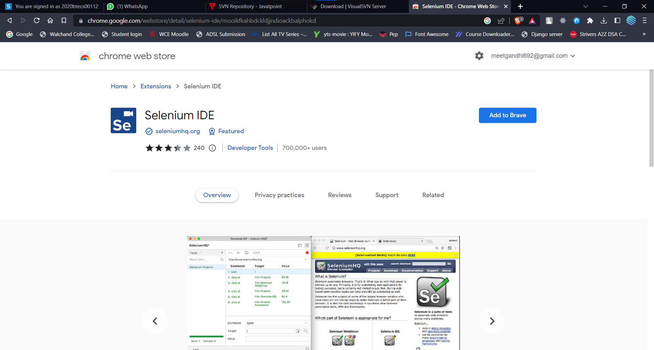

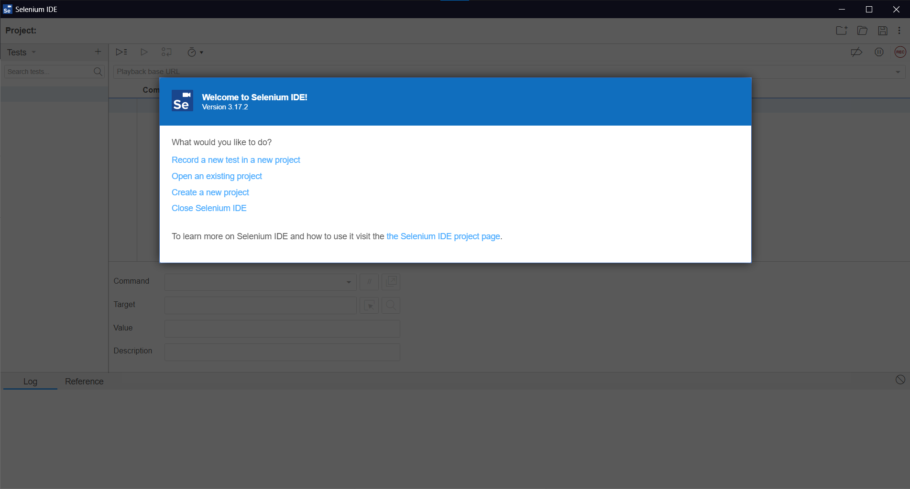

1. Using Selenium tool create multiple test cases (at least 10) on any application/project that you have implemented.

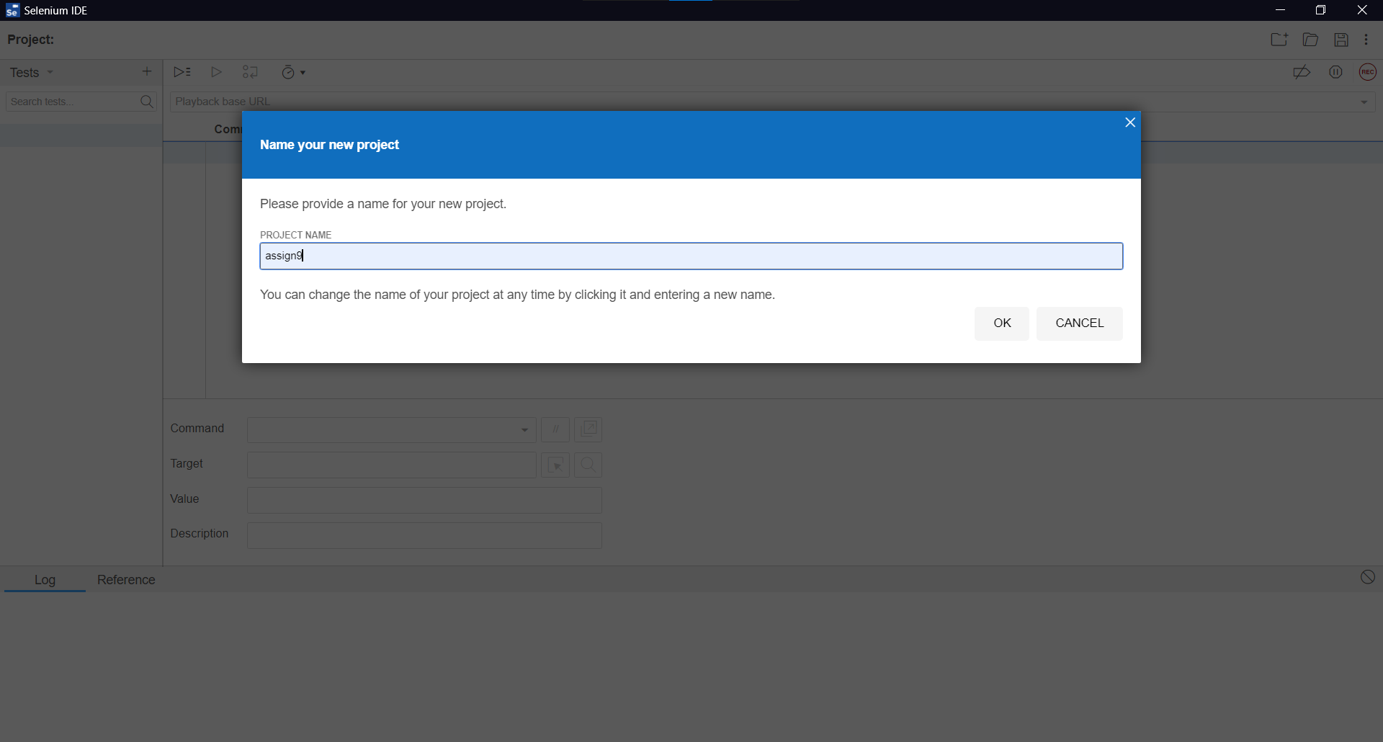

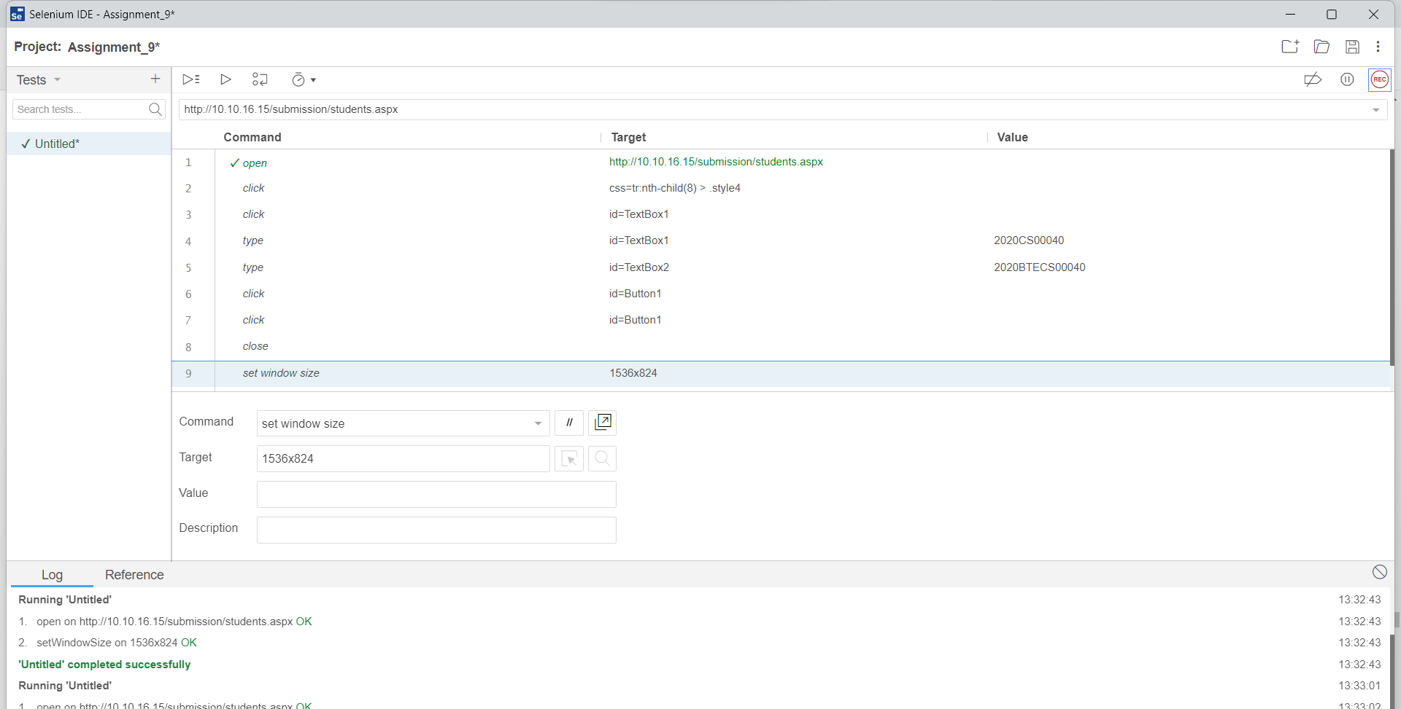

Changing the resolution of window

